|  |
| --- |
| Total Mark:  56 |
|  |



My Target Score: _____ or _____%

MARKING GUIDE

*THE ANCIENT TO THE MODERN WORLD*

Time: 5 minutes reading time and 50 minutes working time.

**Section One – Multiple Choice**

1. History is important because:
   1. History has good ideas
   2. Many of the solutions to modern day problems can be found in history
   3. Those who do not know history are doomed to repeat it
   4. All of the above
2. The feudal system was:
   1. A system of governance in medieval Europe where each group of people had certain duties and obligations to perform
   2. A system of governance in medieval Europe where people voted for their king
   3. A system of governance in ancient history that was used in medieval Europe
   4. A system of social hierarchies where peasants had the most power
3. In the feudal system, knights were given land by who?
   1. The king
   2. Barons
   3. Peasants
   4. Serfs
4. The Crusades lasted for about 200 years. From which dates did the Crusades occur?
   1. 1250-1140 CE
   2. 1195-1992 CE
   3. 1095-1492 CE
   4. 1095-1291 BCE

5. In medieval times education, help for the sick and poor, and accommodation for travellers was provided by the:

1. Church
2. Government
3. King
4. Local lord

6. The wars to capture the Holy Lands were known as the:

1. Crusades
2. Medieval Wars
3. Middle Ages Wars
4. Wars of the Dark Ages

9. Ordeals that were used in medieval Europe to decide if people were innocent or guilty included ordeal by:

1. Ducking stool
2. Red-hot iron and water
3. Disembowelment
4. Pillory
5. What event resulted in the Dark Ages/Middle Ages?
6. Fall of the Western Roman Empire
7. The Black Death
8. Peasant rebellions which destroyed the Feudal System
9. A series of natural disasters, in particular drought, which led to food shortages and starvation
10. The Roman Empire collapsed because:
11. Of constant and ferocious attacks by barbarian tribes such as Huns and Goths
12. Of conflict and civil war within the Empire over who should be Emperor
13. It was simply too big to survive
14. All of the above

1. Why do historians refer to the era from 476 to 800 as the Dark Ages (Early Middle Ages)?
2. Because it was a period of cultural, religious and political struggle.
3. Because of the frequent warfare and disappearance of urban life.
4. They know very little about the era, as many sources have been lost.
5. All of the above.

1. Chivalry was a code of behaviour for:
2. Christian families
3. Young men
4. Knights
5. Serfs/peasants
6. Which of the following characterized the life of a serf/peasant?
7. They couldn’t leave the manor without the lord’s permission
8. They engaged primarily in the manufacture of goods
9. They usually lived in one roomed thatched huts
10. A and C
11. Trial by ordeal was:
12. The way medieval criminals were punished
13. The method by which a persons’ innocence or guilt was determined
14. The method by which knights developed their fighting skills
15. A tactic used by the Normans at the Battle of Hastings
16. Medieval European Kings claimed a “divine right to rule”. What did this mean?
17. The throne would be handed down to the eldest son
18. Their authority was sanctioned by God
19. Militarily they were the strongest and thus had the right to rule
20. They had the support of the people and thus had the right to rule
21. Which one of the following is in its correct chronological order?
22. Dark Ages, Fall of the Western Roman Empire, Battle of Hastings, Crusades
23. Fall of Western Roman Empire, Dark Ages, Battle of Hastings, Middle Ages
24. Fall of Western Roman Empire, Crusades, Renaissance
25. Battle of Hastings, Crusades, fall of the Western Roman Empire

**Section Two – Short Answer**

1. There are eight key concepts for History. Read the following descriptions and state the key concept each is describing (not all key concepts are mentioned): (5 marks)

1. ***Cause and Effect***
2. ***Significance***
3. ***Evidence***
4. ***Contestability or contested***
5. ***Continuity and Change***
6. Refer to Source One and complete the following questions:
7. State the name of the Medieval European system of social hierarchy that Source One depicts. (1 mark)

***Feudalism (other accepted answers could be Feudal Pyramid – use discretion)***

1. Outline the purpose of the Medieval European system of social hierarchy that Source One depicts. (2 marks)

***The purpose of the feudalism system is to display the social hierarchy that dominated life in Medieval Europe. Feudalism was a system that allowed the King to have Power. Through a series of exchanges or land for protection and homage.***

1. Identify an advantage and a disadvantage of this system: (2 marks)

***ADVANTAGES: Protection (mainly for peasants); kings/lords had an army; safer; lower taxes than Roman times; increase in food supply from serfs farming the land; manors self-sufficient (economically, etc).***

***DISADVANTAGES: Peasants treated poorly; taxes could be raised at any time; famine/poverty amongst peasants/serfs; little trade; rigid class system – you were linked to your role & couldn’t escape so no personal freedom; lords rebelled against king – king’s power weekend as nobles had power over the land.***

***Teacher discretion if student’s responses are valid but different from what is outlined above***

1. Choose one of the roles (classes) from Source One and describe their role in the system. (3 marks)

***Dependant on student’s individual response – mark allocations below:***

* ***1 mark for choosing a classes from the system***
* ***1 mark – for correctly outlining their role – what did they provide and receive***
* ***1 mark for referring to the source – using supporting evidence***

***King - RULED & PROTECTED THE COUNTRY.***

***Lords - SUPPLIED MONEY & AN ARMY OF KNIGHTS DURING CONFLICTS***

***Knights - WERE GIVEN LAND BY LORDS IF THEY AGREED TO FIGHT WHEN NEEDED.  
Peasants - WORKED ON THE LAND AND GIVE VASSALS A SHARE OF THEIR PRODUCE. THEY WERE NOT FREE – SO THEY COULD NOT LEAVE THE LAND.***

1. Read the following extract carefully. Use the words provided below to fill in the blanks. (4 marks)

***Answers in order: Knights, noble, fief, serfs***

Nobles with land were worried about it being ravaged by barbarians. They made a promise with warriors or ***knights*** to protect the estate. In return for protection, the **noble** promised to give land to the knight. The land given to the knight was called a ***fief***. This included not only the land but the ***serfs*** or people who worked the land as well.

1. Label the diagram below with the defence features of a castle. (8 marks)

|  |  |  |  |
| --- | --- | --- | --- |
| *Tower* | *Moat* | *Arrow Loops* | *Barbican/gatehouse* |
| *Battlements* | *Bailey* | *Portcullis* | *Drawbridge* |

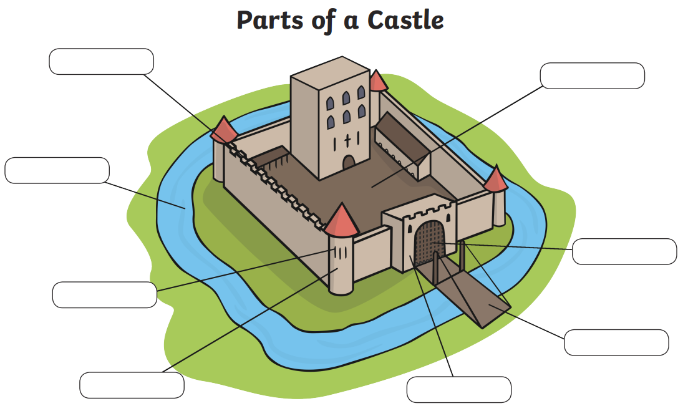

***Battlements***

***Moat***

***Arrow Loops***

***Tower***

***Barbican/gatehouse***

***Drawbridge***

***Portcullis***

***Bailey***

1. Refer to Sources Two and Three and complete the questions that follow:
2. State which event Sources Two and Three are referring to. (1 mark)

**The Crusades**

1. State whether Source Two is a primary or secondary source. (1 mark)

***Primary***

1. With reference to the sources, explain what the Crusades were and why did the crusaders go to war. (4 marks)

***Dependant on student’s individual response – mark allocations below:***

* ***1 mark for a correct definition of what the crusades were – a series of holy wars between the Christian Europeans and the Islamic Turks***
* ***1 mark – for identifying the purpose of the Crusades – for the Christian Europeans to reclaim the holy lands***
* ***1 mark for referring to the source – using supporting evidence***
* ***1 mark for mentioning dates and the unsuccessful outcome of the Crusades***

**Section Three – Extended Response (8 marks)**

**a) PLANNING (2 marks)**

For your chosen question create a brainstorm of ideas/information to help write your response (2 marks)

* ***2 marks for a brainstorm that shows an effective plan for the extended response***
* ***1 mark for an attempted plan – teacher discretion***
  + - * 1. Written response – (the question I am answering is number ___________) (6 marks)

***Depending on which question student’s chose to respond to, marks allocation below:***

***Option 1 - Identify and compare & contrast TWO different groups from Feudal society.***

* ***2 marks for identifying 2 groups explaining who each of the groups were in the system***
* ***2 marks for each description of what the groups did***
* ***2 marks for the discussion of why each group played an important role***

***Option 2 – Discuss Crime and Punishment as a feature of Medieval life***

* ***1 marks for an explanation of why crime and punishment was key in medieval life***
* ***1 mark for examples of crime and punishment from medieval Europe***
* ***1 mark for a description of what has remained the same in Modern times***
* ***1 mark for a description of what has changed compared to now***
* ***1 mark for a discussion of why changes may have occurred***

***FULL marks should only be awarded if all aspects of the above are addressed and the student uses full sentence answers and a well-structured response.***